|  |
| --- |
|  |
| 新概念 3 册 |
| Lesson40 Who’s who |

Book

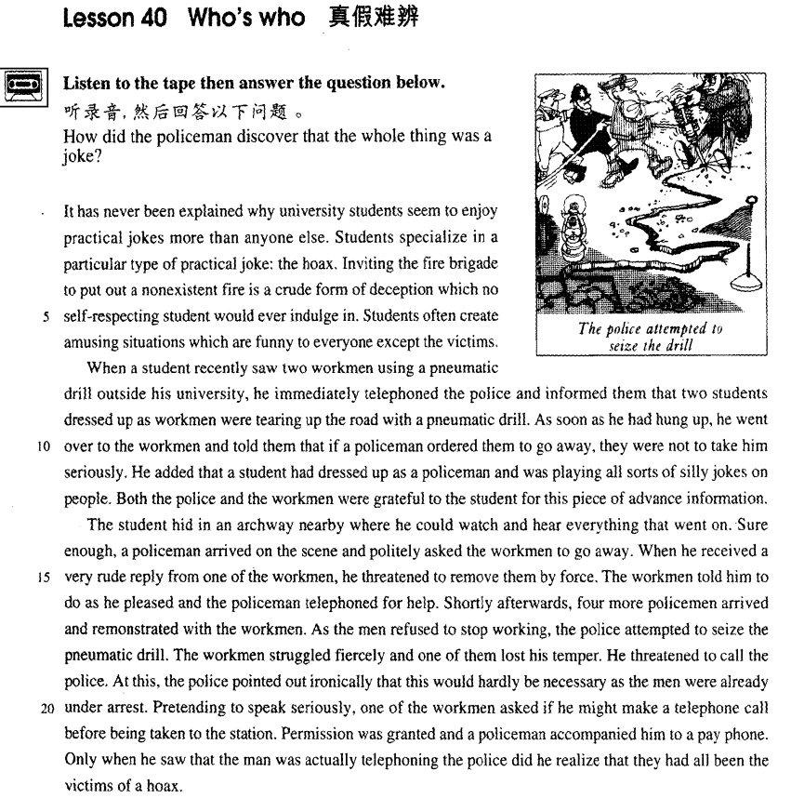

课文

It has never been explained why university students seem to enjoy practical jokes more than anyone else.

谁也弄不清为什么大学生好像比任何人都更喜欢恶作剧。

Students specialize in a particular type of practical joke: the hoax.

大学生擅长一种特殊的恶作剧--戏弄人。

Inviting the fire brigade to put out a nonexistent fire is a crude form of deception which no self-respecting student would ever indulge in.

请消防队来扑灭一场根本没有的大火是一种低级骗局，有自尊心的大学生决不会去做。

Students often create amusing situations which are funny to everyone except the victims.

大学生们常常做的是制造一种可笑的局面，使大家笑上一场，当然受害者是笑不出来的。

When a student recently saw two workmen using a pneumatic drill outside his university, he immediately telephoned the police and informed them that two students dressed up as workmen were tearing up the road with a pneumatic drill.

最近有个学生看见两个工人在学校门外用风钻干活，马上打电话报告警察，说有两个学生装扮成工人，正在用风钻破坏路面。

As soon as he had hung up, he went over to the workmen and told them that if a policeman ordered them to go away, they were not to take him seriously.

挂上电话后，他又马上来到工人那儿，告诉他们若有个警察来让他们走开，不要把他当回事，

He added that a student had dressed up as a policeman and was playing all sorts of silly jokes on people.

还对工人说，有个学生常装扮成警察无聊地同别人开玩笑。

Both the police and the workmen were grateful to the student for this piece of advance information.

警察与工人都对那个学生事先通报情况表示感谢。

The student hid in an archway nearby where he could watch and hear everything that went on.

那个学生躲在附近一拱形的门廊里，在那儿可以看见、听到现场发生的一切。

Sure enough, a policeman arrived on the scene and politely asked the workmen to go away.

果然，警察来了，不礼貌地请工人离开此地；

When he received a very rude reply from one of the workmen, he threatened to remove them by force.

但其中一个工人粗鲁地回了几句，于是警察威胁要强行使他们离开。

The workmen told him to do as he pleased and the policeman telephoned for help.

工人说，悉听尊便。警察去打电话叫人。

Shortly afterwards, 4 more policemen arrived and remonstrated with the workmen.

一会儿工夫，又来了4个警察，规劝工人离开。

As the men refused to stop working, the police attempted to seize the pneumatic drill.

由于工人拒绝停下手中的活，警察想夺风钻。

The workmen struggled fiercely and one of them lost his temper.

两个工人奋力抗争，其中一个发了火，

He threatened to call the police.

威胁说要去叫警察。

At this, the police pointed out ironically that this would hardly be necessary as the men were already under arrest.

警察听后讥讽地说，这大可不必，因为他俩已被逮捕了。

Pretending to speak seriously, one of the workmen asked if he might make a telephone call before being taken to the station.

其中一个工人装模作样地问道，在被带往警察局之前，是否可以打一个电话。

Permission was granted and a policeman accompanied him to a pay phone.

警察同意了，陪他来到一个投币地电话前，

Only when he saw that the man was actually telephoning the police did he realize that they had all been the victims of a hoax.

当他看到那个工人真的是给警察挂电话，才恍然大悟，原来他们都成一场骗局的受害者。

词汇讲解

* **hoax** [həʊks] n. 恶作剧（骗人相信某事）

**hoax** **英文解释：**n. a kind of **practical joke**（恶作剧） in which someone makes people believe something that is not true 恶作剧（骗人相信某事）

**【相关词组】**

**play a joke / trick on sb.** 对某人恶作剧

**make a fool of sb.** 捉弄某人

**cheat sb. out of sth.** 骗走了某人某事

* He **cheated the old lady out of** her fortune.

**trick / deceive sb. into doing** 骗某人做某事

* I was **tricked / deceived into believing** his story.
* **indulge** [ɪn'dʌldʒ]v. 沉迷于……；尽情享受……

**indulge in …** 沉迷于……

* **indulge in** bad habits
* **I indulged** in **a hot bath** / **an expensive dinner** after a day’s hard work.

**做及物动词：**

**indulge / spoil / pamper sb.** 宠爱、娇惯某人

* I don’t agree with **indulging** children.
* a **spoilt** / **pampered** child 宠坏的孩子

**【同根词】**

**indulgent** adj.纵容的；放纵的

**self-indulgent** adj.放纵自己的；任性的

**indulgence** n. 沉溺；放纵；纵容

**self-indulgence** n.放纵自己

* **advance** [əd'vɑ:ns] [əd'væns] adj. 提前的（定语）

**advance** adj. 提前的（定语）

* **advance** **party** 先遣队
* **advance** **notice** / **warning** / **planning** 提前通知/预警/规划
* **advance** **payment** 预付款
* **走遍美国**
* What a job! Good work, Richard!
* *I'm so glad you like them so much.*
* Like them? They represent your best work.
* *Really?*
* Absolutely.
* *Well ... what do you think? Do I have my book?*
* You do. You do.
* There’s a book here. I'll have a contract and an **advance payment** waiting for you, first thing in the morning.

**in advance** （做状语）提前的、预先的做某事

* Rent must be paid one month **in advance**.

**in advance of …** 在…之前

* Galileo’s ideas were **in advance** of the age in which he lived.

**【同根词】**

**advanced** adj. 高级的, 先进的

* **advanced** **technology** 先进的技术
* an **elementary**（基础的） / **intermediate**（中级的） / **advanced**（高级的） English course
* **elementary** / **intermediate** / **advanced** English learners
* **remonstrate** ['remənstreɪt] [rɪ'mɑ:nstreɪt] v. 抗议，规劝，告诫

**remonstrate with sb. (fml.)** 向某人抗议

* The coach angrily **remonstrated with the** referee.
* Shortly afterwards, four more policemen arrived and r**emonstrated with the workmen**.

**【扩展】**

**demonstrate** v. 展示, 表明

**【近义词组】**表达“抗议”：

**protest against …** 聚众抗议

**…… complain (to sb.) of / about sth.** 抱怨/投诉

* Several people **complained of** cat-like noises at night and a businessman on a fishing trip saw the puma up a tree.
* Almost immediately he began to **complain about** the weather, for even though it was still summer, it rained continually and it was often bitterly cold.

**nag sb. to do …** 像某人唠叨…

* When my wife **nagged me to do** something about it, I told her that either I would have to buy a new mower or let the grass grow.

**pester sb. to do …** 纠缠某人做某事…

* From the moment he arrived there, he kept on **pestering his doctor to tell** him when he would be able to go home.
* **ironically** [aɪ'rɒnɪklɪ] adv. 讽刺地

**ironically** / **sarcastically** 讥讽地、讽刺地

* At this, the police pointed out **ironically** that this would hardly be necessary as the men were already under arrest.
* 'Perfume, eh?' he asked **sarcastically**. 'You should have declared that. Perfume is not exempt from import duty.'

**【同根词】形容词**

**ironic** / **sarcastic**

* I was almost there when a **sarcastic** voice below said, 'I don't think the windows need cleaning at this time of the night.'

**【同根词】名词**

**irony** / **sarcasm**

* with heavy **irony** / **sarcasm**
* 'Good of you to arrive on time,' George said, with heavy **irony** / **sarcasm**.

**【扩展】**

**hint** / **trace** / **touch** **of** **irony** / **sarcasm** 讽刺的味道、讽刺的成分在里面

* There was a hint of **irony** / **sarcasm** in her voice.

**sarcastic** 只能用于形容人的语言语气

**ironic** 可以形容人和事物

* the **irony** of fate
* It's **ironic** that she became a teacher ―she used to hate school.
* **Ironically**, his cold got better on the last day of his holiday.

课文讲解

# （标题）

# who’s who

**who’s who** 谁是谁（名字、职务等）

* 《名人录》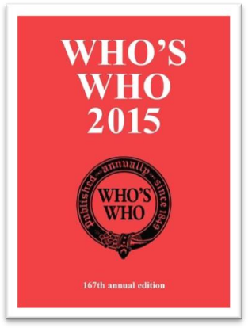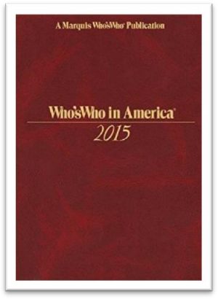
* You’ll soon get to know **who’s who** in the company.

**which is which** 分清楚谁是谁

* The twins are so alike that I can’t tell **which is which**.
* When Scarlet returned to the farm, the old maidservant began to tell her **who married whom**, **who had what children** and so on.

# （第一段）

# It has never been explained why university students seem to enjoy practical jokes more than anyone else.

**语法分析：**

It（形式主语） has never been explained **why** university students seem to enjoy practical jokes more *than anyone else（比较状语)*. （**why**...主语从句）

知识点（1）

**写作：**地道表达

表达“**谁也无法解释**”：

**nobody can explain why …** （中式英语）

**it has never been explained why …** （地道表达，重点突出）

* 造句：谁也无法解释玛雅 (Maya) 文明为什么会突然从地球上消失 (vanish)。
* **It has never been explained why** Maya civilization vanished from the earth.

**【扩展1】**

表达“**我无法理解**”：

表达①：

**I can’t understand / explain why …** （中式英语）

表达②：地道表达

**why … is beyond me** 我无法理解

* **Why** people are prepared to tolerate a four-hour journey each day for the dubious privilege of living in the country **is beyond me**.
* **造句：**我无法理解Jane 为什么愿意 (be prepared to do) 嫁给这样一个懒汉 (lazy-bones)。
* **Why** Jane was prepared to marry such a lazy-bones **is beyond me**.

表达③：地道表达

**it has always been a mystery to me why …** 我无法理解

* **It has always been a mystery to me** why city dwellers, who appreciate all these things, obstinately pretend that they would prefer to live in the country.
* **造句：**我一直搞不懂 John 为什么偏要假装 (obstinately pretend) 喜欢古典乐 (classical music)。
* **It has always been a mystery to me** why John obstinately pretends that he would prefer classical music.
* **听力真题：**

A．She's not sure how she was able to finish so early.

B．She wasn't able to manage the project well.

C．She's not sure how to solve the mystery.

D．She still hasn't heard what was shocking.

* M: I was shocked when I heard you'd finished your research project a whole month early.
* W: How I managed to do **it is still a mystery to me**.
* Q: What does the woman mean?
* Answer: (A) She's not sure how she was able to finish so early.

**【扩展2】**

表达“**人们对某事有争议**”：

表达①：

**People still have different opinions about whether …** （中式英语）

表达②：

**whether … is a moot point at present**

* **Whether** the whole universe does so **is a moot point at present**.
* 造句：人们对是否建造更多公路会减少交通堵塞 (traffic congestion) 尚有争议。
* **Whether** building more roads reduces traffic congestion **is a moot point at present**.

知识点（2） 【课文仿写】

* 造句：谁也无法解释为什么住在地中海地区的人看似比任何人都更爱吃章鱼 (octopus)。
* **It has never been explained why** people who live in the Mediterranean seem to enjoy eating octopus more than anyone else.

# Students specialize in a particular type of practical joke: the hoax.

知识点（1）

**specialize in …** 专门研究……

**specialized** adj. 专业的……

* **specialized** knowledge 专业知识
* **specialized** labour / labor 专业工人
* So great is our passion for doing things for ourselves, that we are becoming increasingly less dependent on **specialized labour**.

知识点（2）

**语法：**如果把表示类型的词放在前面，如sort、kind、type，后面的可数名词可以当不可数名词；如果把表示类型的词放在后面，可数名词放在前面时一般用复数

* a particular **type** of practical **joke**
* practical **jokes** of a particular **type**
* The more expensive **kind of antique shop**（单数） where rare objects are beautifully displayed in glass cases to keep them free from dust **is**（单数） usually a forbidding place.
* Antique **shops**（复数） of the more expensive kind where rare objects are beautifully displayed in glass cases to keep them free from dust **are（**复数） usually forbidding places.

# Inviting the fire brigade to put out a nonexistent fire is a crude form of deception which no self-respecting student would ever indulge in.

**语法分析：**

Inviting the fire brigade to put out a non-existent fire（动名词做主语） is a crude form of deception（名词表语） **which** no self-respecting student would ever indulge in（**which**...定语从句）.

知识点（1）

**put out** = **extinguish** 熄灭、扑灭（不强调方式）

* **put out / extinguish** the **fire** / **cigarette** / **light**

**smother** 压灭（强调方式）

**quench** 用水浇灭（强调方式）

**blow out** 吹灭（强调方式）

知识点（2）

**crude** 冒犯的，粗俗的，粗鲁的

* However, boxing was very **crude**, for there were no rules and a prize-fighter could be seriously injured or even killed during a match.

知识点（3）

**form** n. a type of sth. form of … **类型、种类**

* a severe **form** of cancer
* different **forms** of government

知识点（4）

**no = not any**（后面一般跟单数）没有任何一个

**self-respecting** （一般用在否定句中）有自尊心的

**no self-respecting … would do sth.** 没有自尊心的…会做…

* **No self-respecting** doctor **would** refuse to treat a sick person.
* **No self-respecting** government **would** yield to terrorists.

知识点（5）【课文仿写】

* **造句：**考试中作弊是一种很不光彩的行为 (disgraceful behavior)，任何有自尊的学生都不会去做。
* Cheating in examinations is disgraceful behavior which no self-respecting student would ever indulge in.

# Students often create amusing situations which are funny to everyone except the victims.

**课文替换：**

* Students often create **funny** situations which **are amusing to** / **amuse** everyone except the victims.

# （第二段）

# When a student recently saw two workmen using a pneumatic drill outside his university, he immediately telephoned the police and informed them that two students dressed up as workmen were tearing up the road with a pneumatic drill.

**语法分析：**

**When** a student recently saw two workmen using a pneumatic drill outside his university（分词短语；固定搭配，see sb. doing sth） （**When**... 时间状语）, he immediately telephoned the police *and* informed them **that** two students *dressed up as workmen（非谓语动词、分词做后置定语）*were tearing up the road with a pneumatic drill. （**that**… 宾语从句）

知识点（1）

**telephone the police** 打电话报警

* He told him he had better return it or he would **call the police**.
* At first, she decided to **go to the police**, but …
* **课后题：**
* Mrs. Ramsay was not to **inform the police** （通知警方，不强调方式）and had to pay ₤1,000.

知识点（2） 复习

**inform sb. of sth.** 通知某人某事

**inform sb. that ...**

**convince sb. of sth.** 使某人相信某事

**convince sb. that ...**

**remind sb. of sth.** 使某人回忆起某事

**remind sb. that ...**

**warn sb. of sth.** 警告某人某事

**warn sb. that ...**

**assure sb. of sth.** 让某人对某事放心

**assure sb. that ...**

知识点（3） Lesson13

**dress (sb.) up as ...** 打扮成

* She intended to **dress up as** a ghost ...
* He added that a student had **dressed up as** a policeman …
* They **dressed** him **up as** a gorilla.

**disguise sb. as ...** 把某人装扮成…

* **课后题：**Lesson4
* 2．What did Alfred Bloggs do for over two years? C

(a) He told his wife he worked for the Corporation, when in fact he did not.

(b) He disguised himself as a dustman.

(c) He led a double life.

(d) He earned twice as much as he used to.

* He **disguised himself as** a dustman.

**disguised as ...**（非谓语）装扮成了…模样

* Alfred the Great acted as his own spy, visiting Danish camps **disguised as** a minstrel.
* **课文写法替换：**
* ... two students **disguised as** workmen were tearing up the road with a pneumatic drill.

知识点（4）

**tear up sth.** 1.开凿路面；2.撕碎

* The plumbers **tore up the road**（开凿路面） to lay a new water main.
* He **tore up** （撕碎）the letter with anger.

**tear** 撕扯

* The child’s misery **tore** my heart.

**tear sth. in half / two** 把某事一撕两半

**tear sth. to pieces**  把某事撕成碎片

**tear sth. away** 把某事撕掉

* In August, she was struck by a very heavy storm during which her rudder was **torn away**.

# As soon as he had hung up, he went over to the workmen and told them that if a policeman ordered them to go away, they were not to take him seriously.

**语法分析：**

As soon as he had hung up（时间状语从句）, he went over to the workmen and told them ***that*** *if a policeman ordered them to go away（条件状语从句）, they were not to take him seriously*. （**that**… 宾语从句）

知识点（1）复习、总结

**【相关词组】**引导时间状语，表达“刚一…就…”：

**as soon as ...**

**immediately** / **directly** **...** （充当连词）

**the moment ...** （充当连词）

**on** / **upon** ...

**no sooner ... than ...** no sooner（副词短语，先发生） ... than（连词，后发生） ...

**hardly / barely / scarcely ... when / before ...** hardly / barely / scarcely否定词放在句首要部分倒装

* **课文写法替换：**
* **Immediately** / **Directly** he had hung up, ...
* **The moment** he had hung up,
* ... **On** / **Upon** hanging up, ...
* He **had no sooner** hung up **than** he went over to ...
* **No sooner** ***had***he hung up than he went over to ...
* He **had hardly** hung up **when** he went over to ...
* **Hardly** ***had***he hung up **when** he went over to ...

知识点（2） Lesson33

**hang up** 挂电话

* You **hang up** hurriedly and attend to baby, crockery, etc.

**put the phone down** 挂电话

**slam the phone down** 生气的挂电话

**get cut off** 断线了

* **托福听力真题：**

A．Eating in a cafeteria.

B．Buying something in a store.

C．Talking on the telephone.

D．Getting money at a bank.

* M: Did you **get cut off**?
* W: No, they asked me to **hang up** and try again later.
* Q: What has the woman been doing?
* Answer: (C) Talking on the telephone.

知识点（3）

he went **over** to …

**over** 表示个跨度，从那边到这边

* He’s seen me! He’s coming **over**!
* **托福听力真题：**

A．She wants to check the weather before deciding.

B．She has a problem with her hearing.

C．She’d enjoy coming to dinner another time.

D．She wants the man to help her with some work.

* M: Can you come **over** for dinner tonight?
* W: I’m up to my ears in work, so I’ll have to take a rain check.
* Q: What does the woman mean?
* Answer: (C) She’d enjoy coming to dinner another time.
* 走遍美国:：
* Hello. This is Richard Stewart. My wife, Marilyn Stewart, is a member of your program. I’d like to come to the ten o’clock advanced class this morning.
* *Oh, fine, fine. Be here a few minutes early. You need to complete some forms before the class.*
* Thanks. I’m on my way **over**. Good-bye.
* Bye-bye.

知识点（4）

…they **were not to take**（应该） him seriously.

**语法：be to do** (fml.) 的四种用法

用法①： **打算**

* I’**m to see her** tomorrow.

用法②：**命令**

* You’**re to be back** by 10 o’clock.
* No one **is to leave** the building.

用法③：**能够**

* How **am I to** pay such a debt?
* We **are not to be** bullied.

用法④：**应该**

* Such men **are to be pitied** rather than despised.
* Some books **are to be** tasted, others **to be** swallowed, and some few **to be** chewed and digested. — Francis Bacon

# He added that a student had dressed up as a policeman and was playing all sorts of silly jokes on people.

**语法分析：**

He added **that** a student had dressed up as a policeman and was playing all sorts of silly jokes on people. （**that**… 宾语从句）

知识点（1） 复习、总结

**add** v. 补充说

* Then I **added** with a smile, ‘It’s a strange mixture I make myself.’

**threaten** 威胁说

* When he received a very rude reply from one of the workmen, he **threatened** to remove them by force.

**point out** 提醒说

* At this, the police **pointed out** ironically that this would hardly be necessary as the men were already under arrest.

**claim** 声称说

* However, as the evidence began to accumulate, experts from the Zoo felt obliged to investigate, for the descriptions given by people who **claimed** to have seen the puma were extraordinarily similar.

**confirm** 证实说

* It immediately ran away when she saw it, and experts **confirmed** that a puma will not attack a human being unless it is cornered.

**complain** 抱怨说

* Several people **complained** of ‘cat-like noises’ at night and a businessman on a fishing trip saw the puma up a tree.

**put it** 措辞说

* …, as one of them **put it** ‘ate like kings’.
* I don’t know how to **put it**.

**state** 声明说

* The writer **stated** that Rastus was in safe hands …

**explain** 解释说

* She **explained** that Rastus was very dear to her.

**mumble** 自言自语说

* He was still **mumbling** (mumble) something about hospitals at the end of the party when he slipped on a piece of ice and broke his left leg.

**nag** 唠叨说

* When my wife **nagged** me to do something about it, I told her that either I would have to buy a new mower or let the grass grow.

知识点（2） 复习

**play a joke / trick on sb.** 开某人玩笑

* One night, the gaoler decided to **play a joke on** his colleague to find out if, after so many performances, he had managed to learn the contents of the letter by heart.

知识点（3）

**all sorts / kinds / types of sth.** 各种各样的

* She has to deal with **all kinds of** complaints.

# Both the police and the workmen were grateful to the student for this piece of advance information.

知识点（1）Lesson15

**be thankful / grateful / obliged / indebted to sb. for sth.** 因为某事感谢某人

* I’**m thankful to** you **for** your **help**.
* I’**m** much **grateful to** you **for** your advice.
* I’**m** deeply **obliged to** you **for** your encouragement.
* I’**m** most **indebted to** you **for this** piece of advance information.

【相关词组】

I appreciate your help / it.

I owe you (one).

# （第三段）

# The student hid in an archway nearby where he could watch and hear everything that went on.

**语法分析：**

The student hid in an archway nearby **where** he could watch and hear everything **that** went on（**that**...定语从句）. （**where**...定语从句）

知识点（1）复习

 **archway** 拱道；拱门

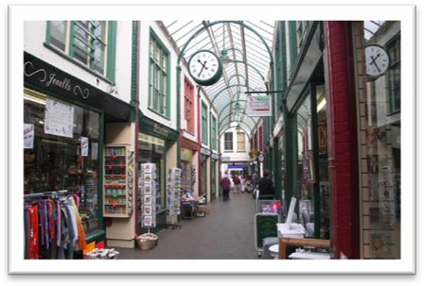**arcade**

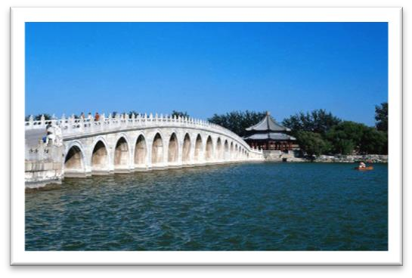 **17-Arch Bridge**

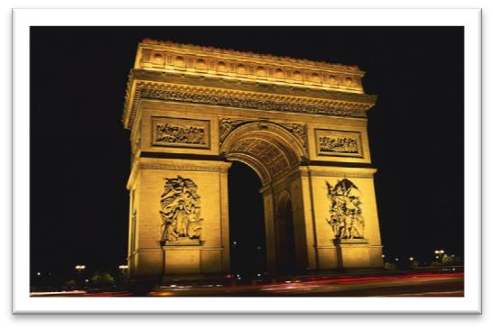 **Arch of Triumph**

知识点（2）

* … an archway **nearby** … （nearby副词）
* a **nearby** archway （nearby 形容词）
* ~~a near archway~~ ☓（near不能做“距离”前置定语）
* The archway is very **near**. （near做表语）
* in the **near** future （near做前置定语，形容“时间”上的近）
* a **near** relative （near做前置定语，形容“关系”上的近）

知识点（3） 复习

**语法**：定语从句充当并列句

* The monks prefer winter to summer for they have more privacy.
* **造句**：我的暑假是在乡下度过的，在那儿我可以更不受打扰地生活。
* I spent my summer vacation in the country **where** I had more privacy.

# Sure enough, a policeman arrived on the scene and politely asked the workmen to go away.

知识点（1） 复习

**sure enough** 果然

* **Sure enough**, Rastus arrived punctually at seven o'clock that evening.

知识点（2）

**on the scene / spot** 在现场，到现场

* Meanwhile, two other actors, Rockwall Slinger and Merlin Greeves, had carried two large food baskets to a shady **spot** under some trees.

**on the spot** 当场……, 立即……

* He would invent fanciful names **on the spot**.

# When he received a very rude reply from one of the workmen, he threatened to remove them by force.

知识点（1） 复习

**receive + n.** 受到了……; 得到了……; 遭到了……

* These young people, who love the peace of mountains, always **receive** a warm welcome at St. Bernard's monastery.
* No creature has **received** more praise and abuse than the common garden snail.
* This exhibition **received** a great deal of attention in the press, for though the pictures were supposed to be the work of famous artists, they had in fact been painted by Dickie.
* The majority of the patients attending the medical out-patients departments of our hospitals feel that they have not **received** adequate treatment unless they are able to carry home with them some tangible remedy in the shape of a bottle of medicine, a box of pills, or a small jar of ointment, …
* **receive** support 得到支持
* **receive** good education 收到好的教育
* **receive** a heavy blow 遭到重击
* **receive** a serious injury 受到严重伤害

知识点（2）

**threaten to do** 1. 威胁说……；2.有……的危险

* We keep trying all four methods, but the sheer volume of rubbish we produce worldwide **threatens to** overwhelm （有……的危险）us.

# The workmen told him to do as he pleased and the policeman telephoned for help.

**语法分析：**

The workmen told him to do as he pleased（方式状语）（ and the policeman telephoned for help.

知识点（1）

**please** v.高兴, 乐意

* Come whenever you **please**.

# Shortly afterwards, 4 more policemen arrived and remonstrated with the workmen.

shortly afterwards 不久之后

remonstrate 规劝

# As the men refused to stop working, the police attempted to seize the pneumatic drill.

# The workmen struggled fiercely and one of them lost his temper.

**lose one’s temper** 发火了

**【反义】**

**keep one’s temper** 忍住不发脾气

# He threatened to call the police.

# At this, the police pointed out ironically that this would hardly be necessary as the men were already under arrest.

**语法分析：**

*At this（介词短语做状语）*, the police pointed out ironically（副词做状语） **that** this would hardly be necessary *as the men were already under arrest（原因状语从句)*. （**that**… 宾语从句）

知识点（1）

**语法：**在英语中，**this** 和 **that** 均可**前指**，但一般只有 **this** 可以**后指**。

* He threatened to call the police. At **this**（前指）, the police pointed out ironically that …
* Finding that he could not remember a word of the letter either, the gaoler replied: 'The light is indeed dim, sire. I must get my glasses.' With **this**（前指）, he hurried off the stage.
* To be, or not to be: **that**（前指） is the question. — Shakespeare
* Good friends, good books and a sleepy conscience: **this** （前指）is the ideal life. — Mark Twain
* Of all men's miseries the bitterest is **this**（后指）: to know so much and to have control over nothing. — Herodotus

知识点（2）

**point out** 指出，提醒说

* Franz poured scorn on the idea, **pointing out** that his brother had been killed in action during the war.

知识点（3）

**be under arrest** 被捕

**be under + n.** 处于某状态

* The car **is under** repair. 在修理之中
* The castle **is under** attack. 在遭受攻击之中
* The subject **is under** discussion. 在讨论之中
* The matter **is under** consideration. 在考虑之中
* The patient **is under** observation. 在观察之中
* The case **is under** investigation. 在调查之中
* The bridge **is under** construction. 在建造之中
* The building **is under** renovation. 在整修之中

# Pretending to speak seriously, one of the workmen asked if he might make a telephone call before being taken to the station.

**语法分析：**

Pretending to speak seriously（非谓语动词作状语), one of the workmen asked **if** he might make a telephone call *before（介词） being taken to the station*. （**if**… 宾语从句）

知识点（1） Lesson4

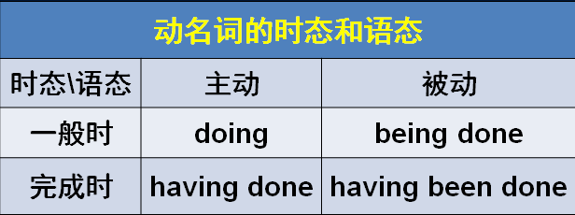

# Permission was granted and a policeman accompanied him to a pay phone.

知识点（1）

**give / grant (sb.) permission** 给某人许可

**refuse / deny (sb.) permission** 拒绝请求

* The police granted him permission and a policeman … （不地道，不简洁）
* **造句：**他问老师他是否能打个电话。老师不允许他这么做，于是他只好等到下课。
* He asked the teacher if he might make a telephone call. **Permission was denied** and he had to wait until the class was over.

知识点（2）

**pay phone / pay station** 公共电话

# Only when he saw that the man was actually telephoning the police did he realize that they had all been the victims of a hoax.

**语法分析：**

Only **when** he saw that the man was actually telephoning the police （**when**...时间状语从句） *did (only+状语位于句首，后面句子要部分倒装)* he realize *that they had all been the victims of a hoax*. （that… 宾语从句）

知识点（1）Lesson5

**only +状语** 翻译为“只有、仅有”；如果是时间状语翻译为“直到”

**语法：**复习“**only + 状语**”位于句首，用部分倒装

* **Only**（直到） then *did* he realize that he was mistaken.
* **Only**（只有） by working hard *can* we succeed in doing anything.
* **Only**（直到） after a baby seal is pushed into the sea by its mother *will* it learn how to swim.
* **Only**（直到） when he saw that the man was actually telephoning the police *did* he realize that they had all been the victims of a hoax.